
Year 12 Essentials Unit 3
Task 2 – Response Test 1
Measurement & Scale

Name Teacher

Section | Marks Available | Your Score
Non Calculator | 17
Calculator Assumed | 33
Total | 50
Percentage | 100%
Weighting | 10%

INSTRUCTIONS TO STUDENTS:
- All questions in this test are to be attempted.
- If a question is worth more than 1 mark, then working out is required to achieve full marks for that question.

TIME ALLOWED:
- One lesson

TO BE PROVIDED BY THE TEACHER:
- Test Paper

TO BE PROVIDED BY THE STUDENT:
- Stationery items - Pen, Pencil, Eraser, Sharpener and Calculator (only for the calculator assumed section).

Remember, it is YOUR responsibility to bring the required equipment into the assessment.

Section 1 – Non-Calculator

- Convert the following measurement to the units specified: [1,1 = 2 marks]

- 5250 cm = ___________m b) 0.025 km = ___________m

- Calculate the perimeter of the shapes below: [1,1 = 2 marks]

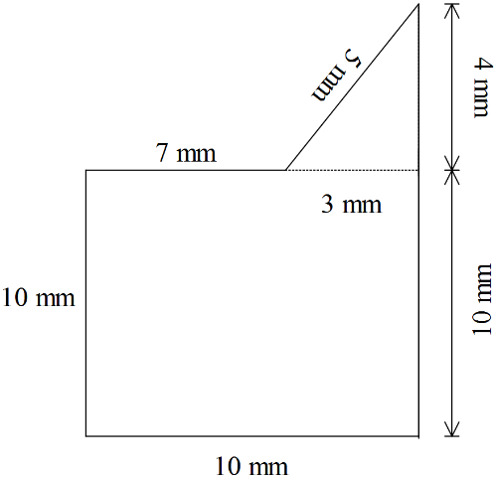
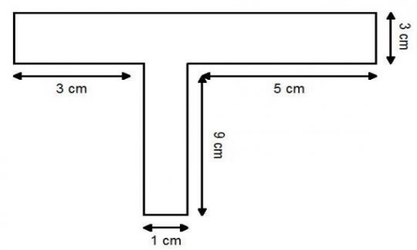
- b)

- Draw the following drawing of the following shapes: [1,1,1,1,1,1 = 6 marks]

- Calculate the area of the following shapes: [1,1,3 = 5 marks]
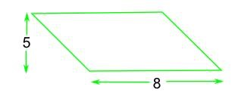
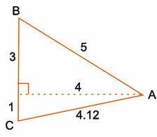
- b) c)
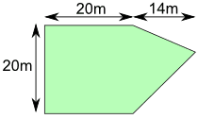

- Calculate the volume of the following shapes: [1,1 = 2 marks]
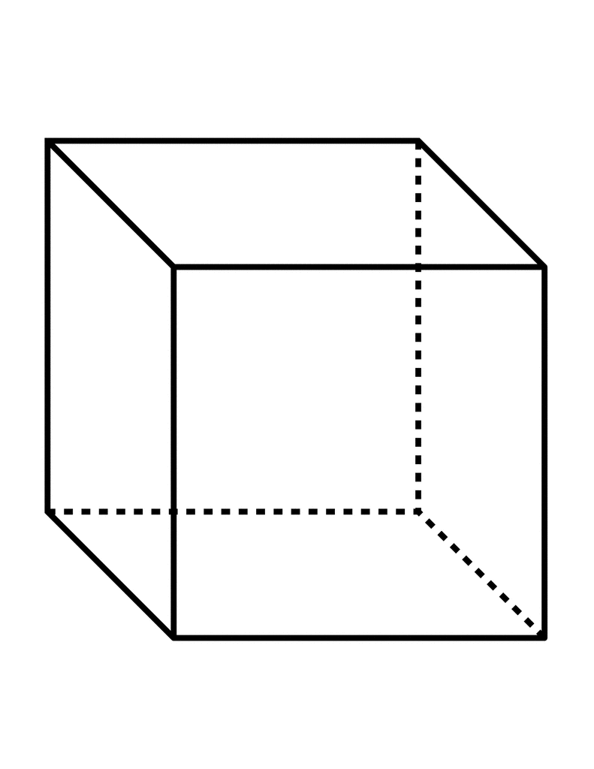
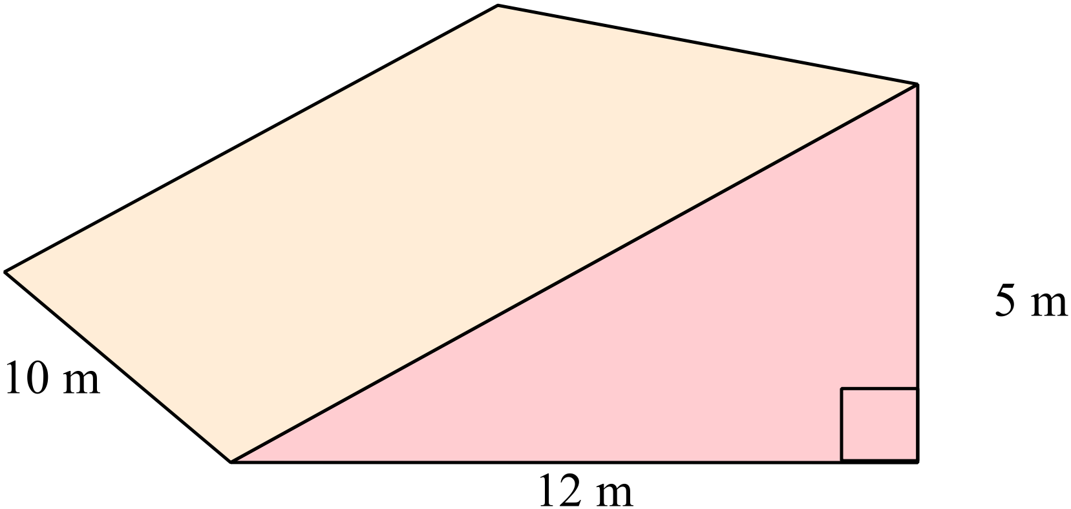
a) b)

$$l=5 cm$$

Section 2 – Calculator Allowed

- Convert the following measurement to the units specified: [1,1,1,1 = 4 marks]

- 7500 cm³ = m³ b) 0.185 m³ = cm³

- 9 787 200 mm³ = m³ b) 5 m³ = mm³

- Match the nets with the following shapes: [1,1,1,1 = 4 marks]
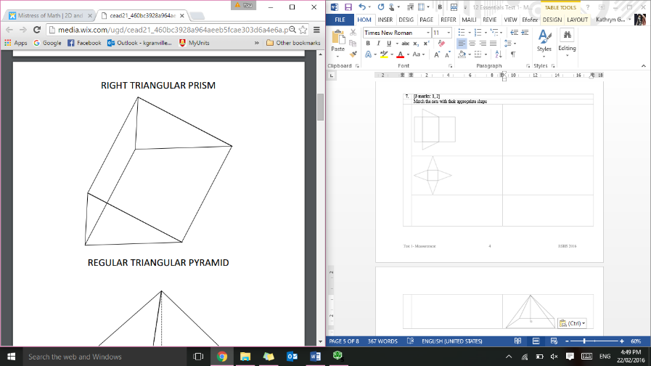
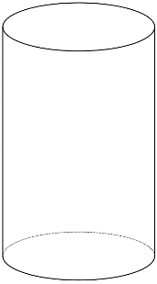
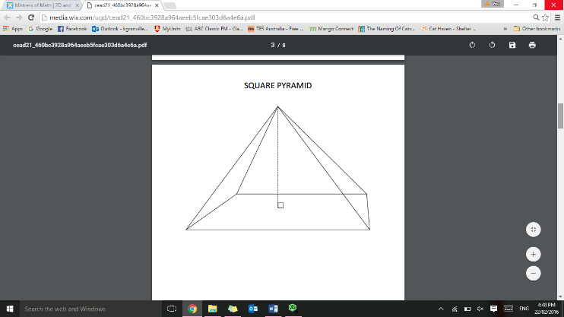
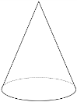

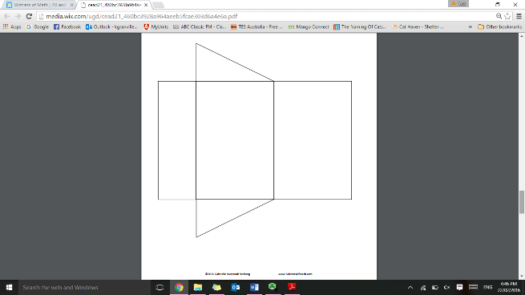
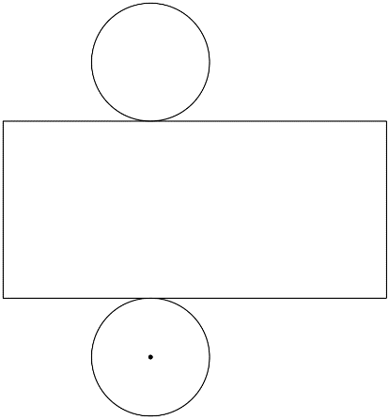
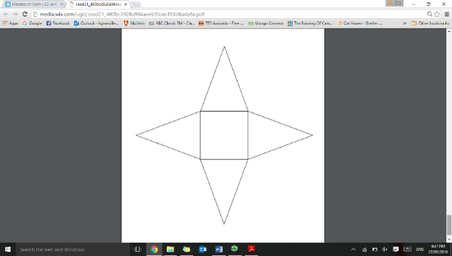
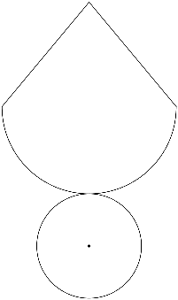

- Calculate the area of the following shapes: [4,3,4 = 11 marks]
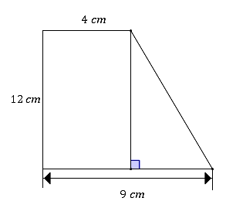
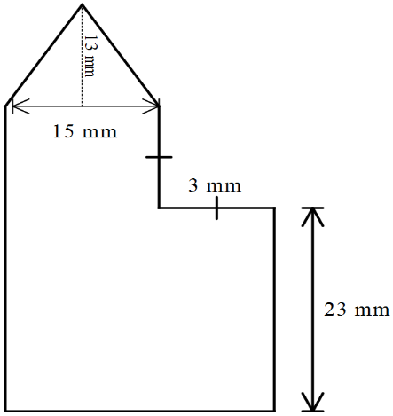
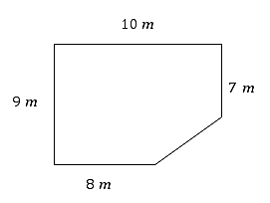
a) b) c)

- Calculate the volume of the following shapes: [1,1,3 = 5 marks]
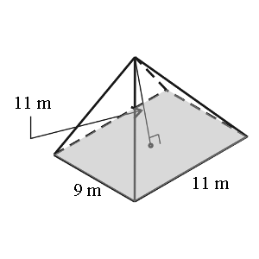
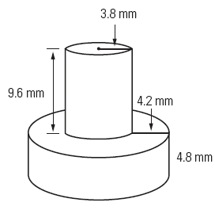
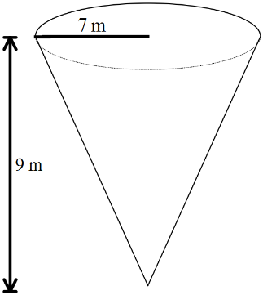
a) b) c)

- Brandy has an old open faced cabinet that she needs to repaint. She is repainting both the outside and the inside surfaces. Calculate the total surface area to be painted. [2 marks]
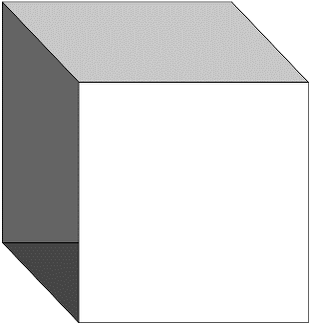

45.5 cm

32

cm
24.6 cm

- Below is the floor plan for Miss Granville’s new holiday home: [2,2,3 = 7 marks]

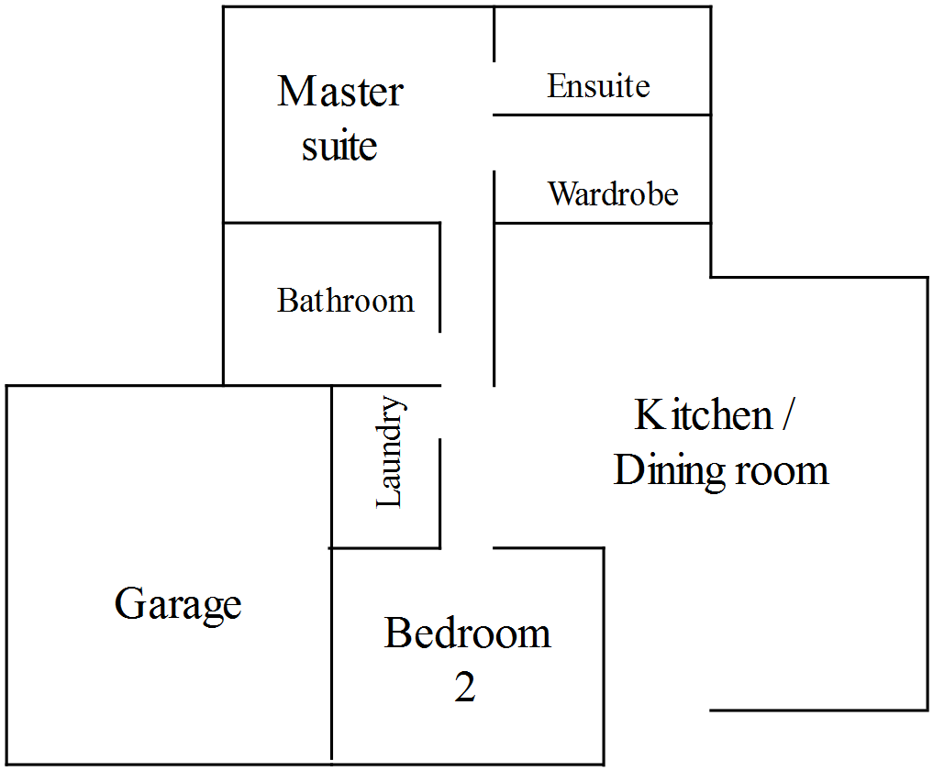

Scale 1:200

- Using the scale given, find the area of the garage.

- Miss Granville decides that she wants to concrete the floor of the garage. If concrete costs $21.20 per square metre, how much will it cost to complete?

- The bathroom, laundry and ensuite are to be tiled, with tiles costing $41.40 per m². How much will it cost to buy tiles?

